**GLASGOW GUARANTEE**

**Registration Process for College Leavers**

**ELIGIBILITY**

All candidates MUST:

* **Live** within Glasgow City Council postcode boundary
* Be due to leave College (Summer and Winter leaving dates)
* Be unemployed/underemployed (part time or 0 hours contract)
* Be eligible to work in the UK
* Have recourse to receive public funds

There is 1 entry route to register:

* Eligible to leave college 3-4 months prior to the official college leaving date
  + Winter Leavers: 1st October – 31st December
  + Summer Leavers: 1st March – 30th June

**2 STEP REGISTRATION PROCESS**

The registration process includes the following steps:

* Online registration form
* Uploading eligibility documents

Candidates will have access to their account and be able to view vacancies after they submit the online registration form, however they **WILL NOT** **be able to apply** for any vacancies, until all the above areas are complete, and the candidate has been approved by Glasgow Guarantee.

**Registrations can only be approved once all steps have been completed and College leaving date is verified.**

**GETTING STARTED**

To Register with Glasgow Guarantee, go to [www.glasgowguarantee.org](http://www.glasgowguarantee.org) and click on **#MAKE IT WORK** to complete the registration information page.

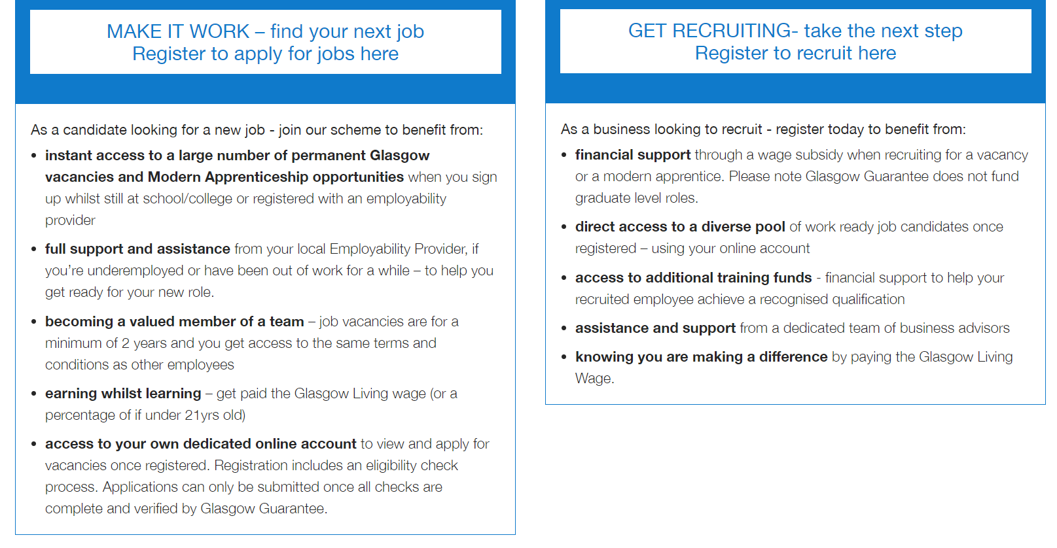

**PRIVACY POLICY**

As we are asking for personal information about you, we have a Privacy Policy which explains how we keep your information. To find out how we will process and use your personal information, go to <https://www.glasgowguarantee.org/Home/PrivacyPolicy>

**STEP 1: ONLINE REGISTRATION FORM**

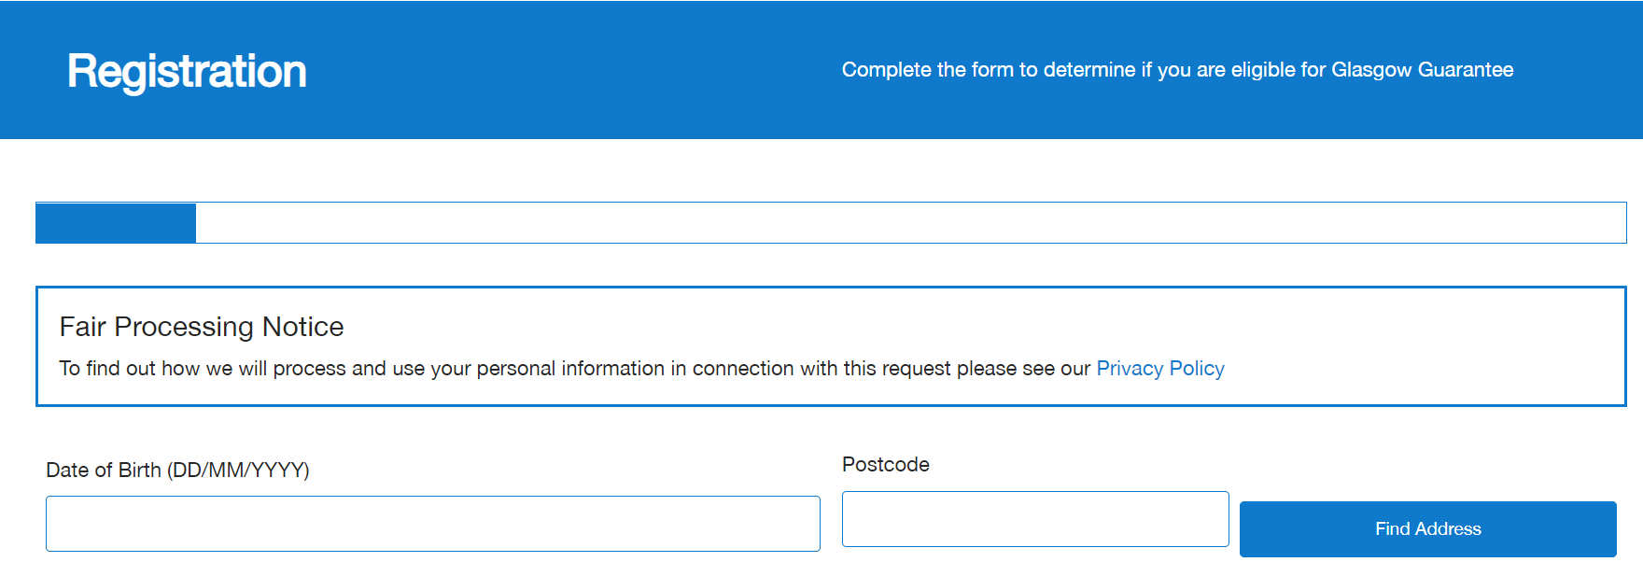

1. Enter date of birth
2. Enter a valid Glasgow City Council postcode. To check that the postcode is within Glasgow City, please access [www.gov.uk/find-local-council](http://www.gov.uk/find-local-council)

Click FIND ADDRESS



1. Select address from the drop-down list

**STEP 1: ONLINE REGISTRATION FORM**

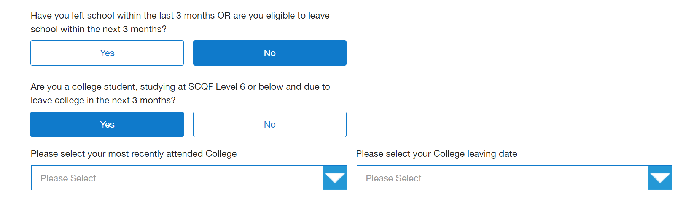

1. Have you left school within the last 3 months OR are you eligible to leave school within the next 3 months?
   1. This question will only come up if you are of school leaving age
   2. Select **NO**
2. Are you a college student, studying SCQF Level 6 or below and due to leave college in the next 3 months?
   1. Select **YES**
3. Select the College you attend from the available drop-down list
4. Select your College leaving date
   1. Select Winter if you leave between October and December
   2. Select Summer if you leave between March and June



1. Are you eligible to work in the UK?
   1. Select YES or NO
   2. If NO, you will not be eligible for Glasgow Guarantee



1. Do you need a VISA to work in the UK?
   1. Select YES or NO
   2. Accepted VISA for registration include:
      1. Indefinite leave to remain/settlement
      2. UK Partner Visa – EEA Family Permit

**STEP 1: ONLINE REGISTRATION FORM**

**PERSONAL DETAILS:**

## This graphic shows the personal details to be completed in the personal details section of the on-line form.

1. There are 4 mandatory fields in the personal detail section. Please complete these
   1. First name (optional Middle name)
   2. Last name
   3. Date of Birth
   4. National Insurance Number  
      If you don’t have a National Insurance number, please contact Glasgow Guarantee at [Guarantee@glasgow.gov.uk](mailto:Guarantee@glasgow.gov.uk)
2. Initial Employment Status - please select **Economically Inactive** in this dropdown
3. Complete Address One, Two, Three and Town as required. Continue to complete the form, your postcode will be automatically included

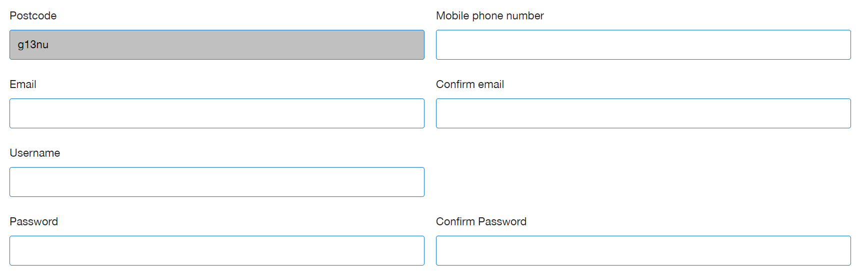

1. Add in your mobile number and your valid email address
2. Create a Username and Password
   1. Think of a username and password that you’ll remember

**STEP 1: ONLINE REGISTRATION FORM**

**EQUALITY AND DIVERSITY:**

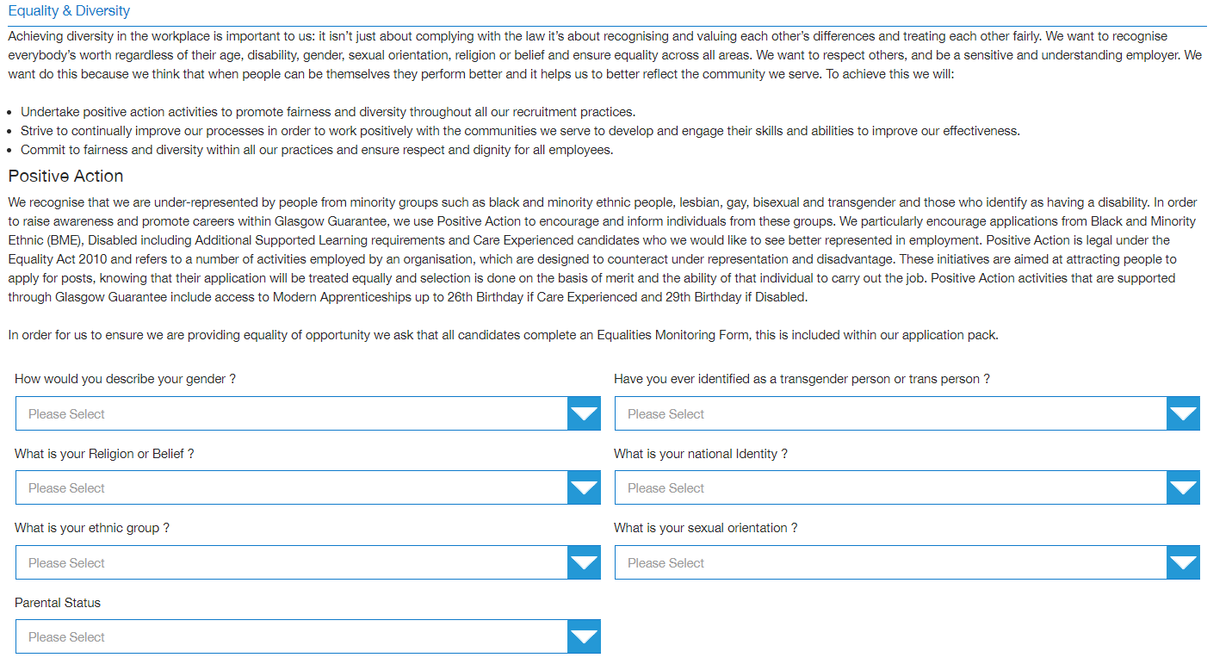

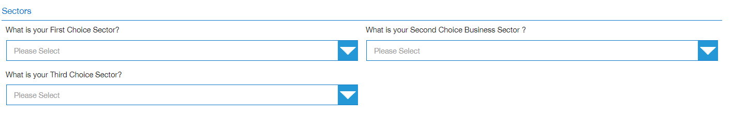

1. Complete the equality and diversity form
2. Career sectors should be selected in order of preference – first, second and third choice. These can be changed once your registration is approved

**STEP 1: ONLINE REGISTRATION FORM**

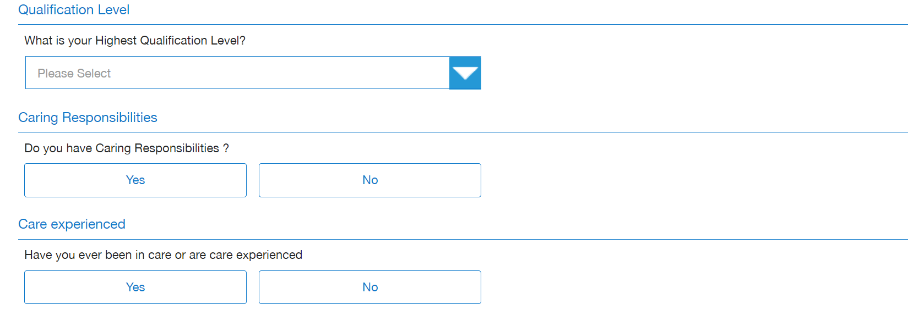

1. Qualification Level – select the highest level of qualification achievement you have gained from the dropdown list e.g. National 4, Higher



1. Please indicate if you have a disability and require any adjustments if successful in an interview with an employer

**STEP 1: ONLINE REGISTRATION FORM**

1. Barriers should be selected if they are relevant to your current circumstances. Click on the **“?”** to reveal the definition of each barrier. Multiple barriers can be selected in this section. Definitions are as per ESF Guidance - <https://www.gov.scot/publications/european-social-fund-participant-guidance/>

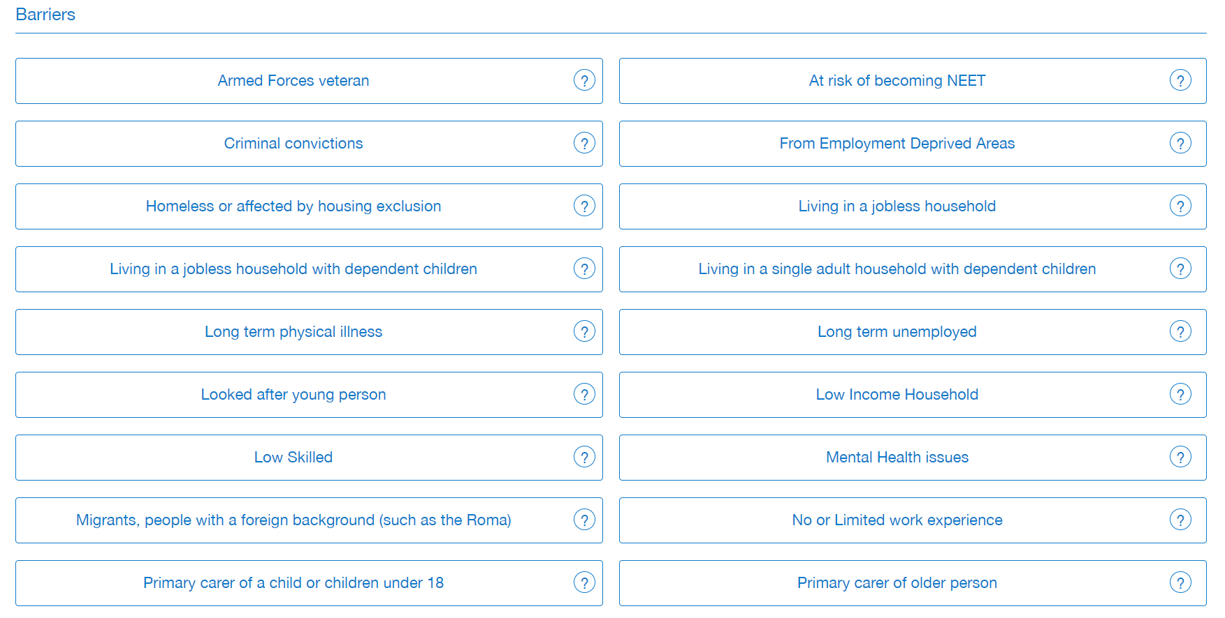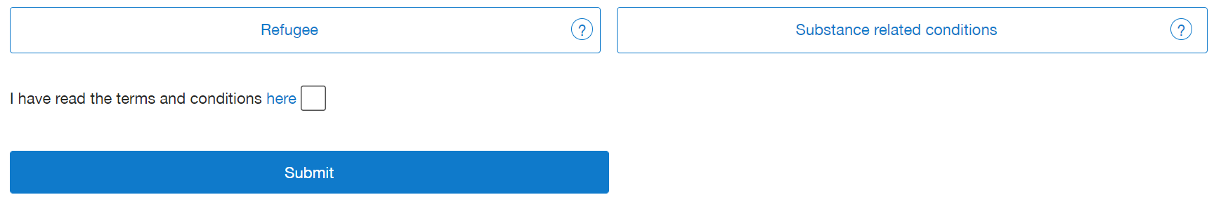

1. Read the terms and conditions and data protection information (you can read this via the link below)
   1. [www.glasgowguarantee.org/CandidateRegistration/Index#](http://www.glasgowguarantee.org/CandidateRegistration/Index)
   2. Tick the box
2. Submit your online registration form

**Once you submit your registration form, you will be automatically logged in to your account, but you will not be approved at this stage. You will be able to view vacancies but WILL NOT be able to apply until you complete the full registration process and have been approved by Glasgow Guarantee.**

**IF USING A PUBLIC PC, PLEASE DO NOT AUTOSAVE YOUR USERNAME AND PASSWORD – other people using the PC after you will be able to log in to your account**

**EMAIL ADDRESS VERIFICATION**

**Once you submit your online registration form, you are automatically signed into your account.**

**You will also receive an email containing a link to validate your email address. We will send you an email (see below) to the email address you provided on your online registration form.**

**Please note, your registration WILL be progressed if you decide not to validate your email.**

***Example email:***

*Thank you for registering with the Glasgow Guarantee. You are now able to validate your email address and can do this by clicking on this link*

*Please note, your registration WILL be progressed if you decide not to validate your email*

Kind Regards  
  
Glasgow Guarantee Team

**When you are logged in to your account, your dashboard will look like below:**

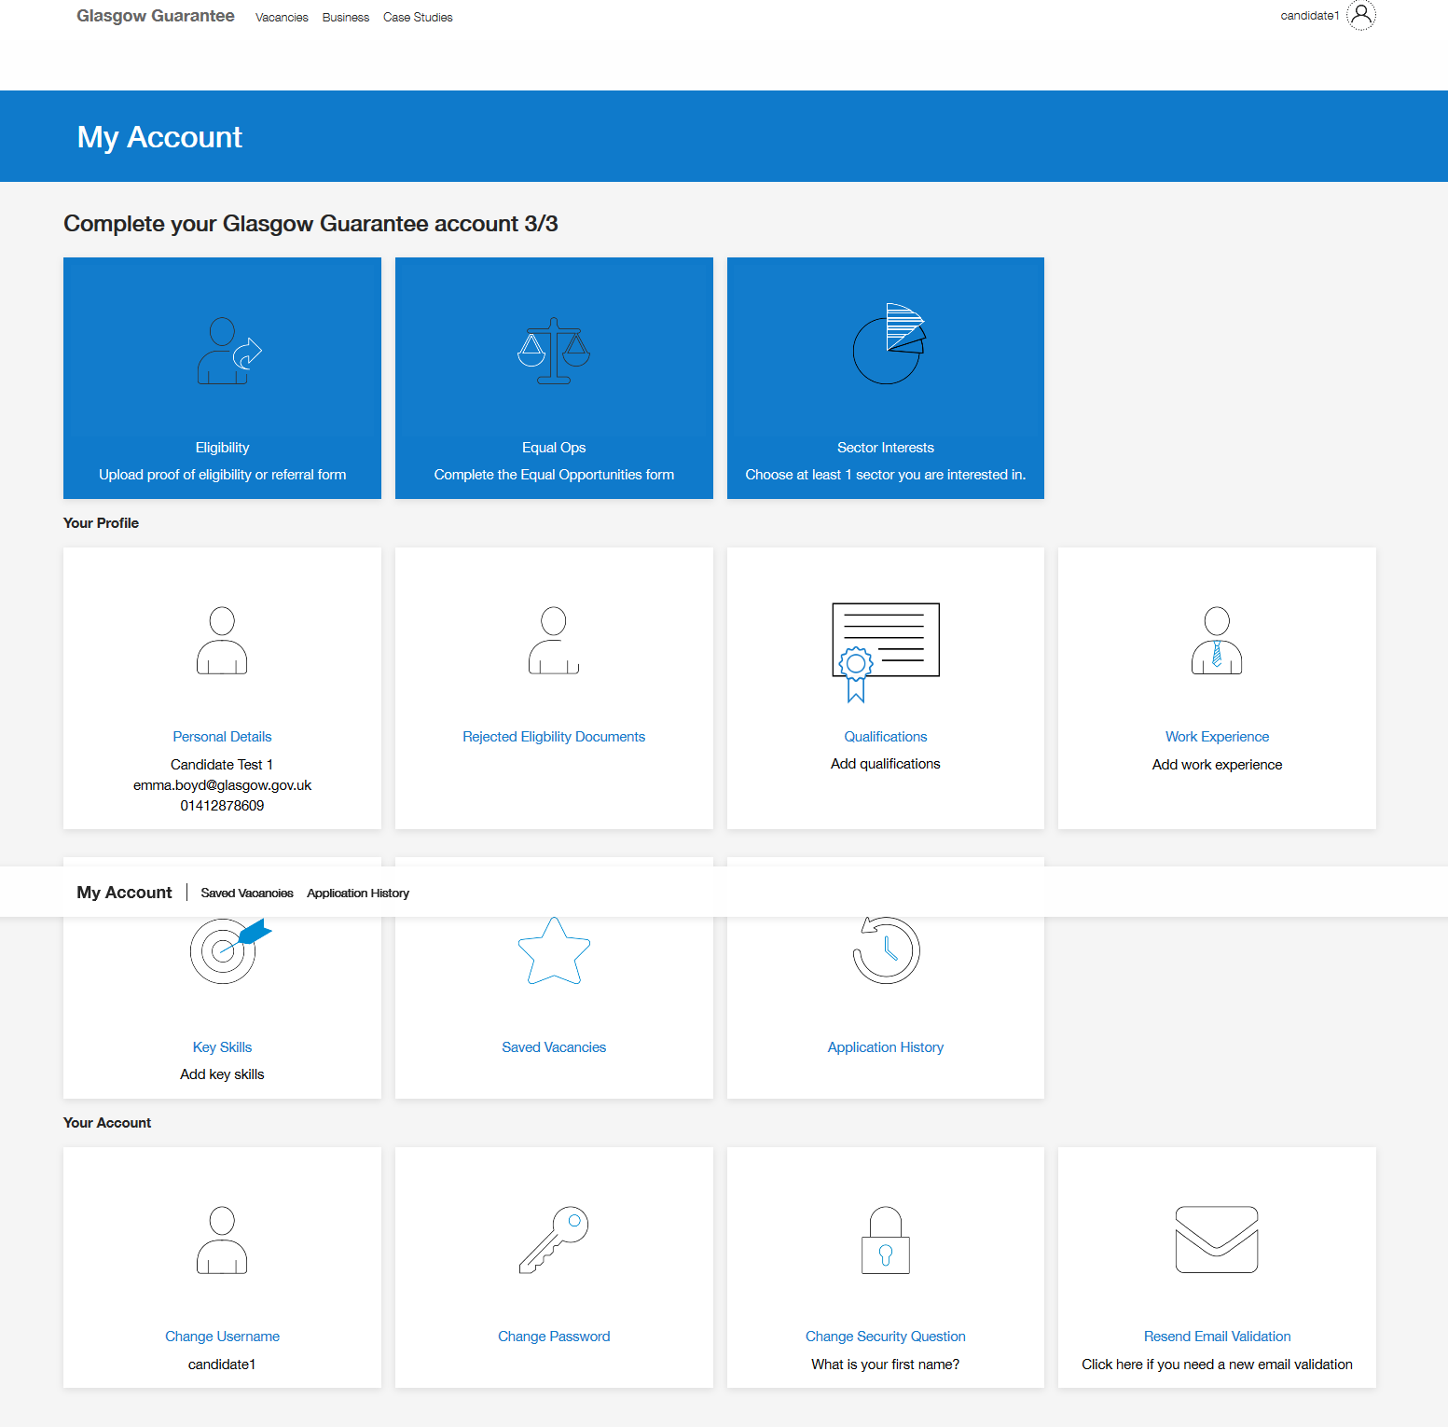

**STEP 2: UPLOADING ELIGIBILITY DOCUMENTS:**

To complete the registration process, you **MUST** upload documents to the Eligibility Check section:

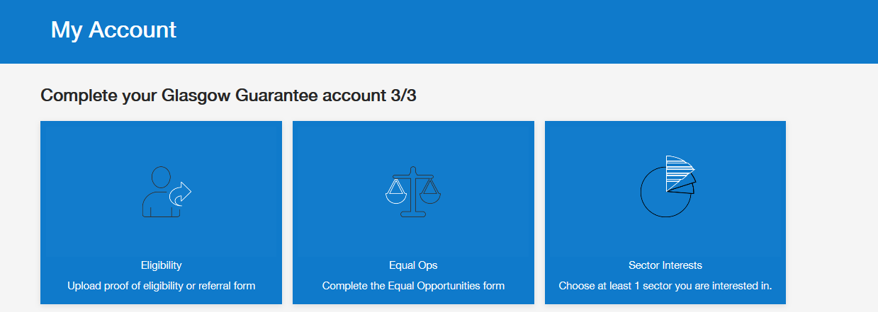

There are 3 mandatory document categories:

1. Proof of Address (**letters must be dated within the last 12 months**)
   1. Bank Statement
   2. Council Tax Letter
   3. Driving Licence (full or provisional)
   4. NHS Medical Card
   5. Official Correspondence (DWP, HMRC, NHS)
   6. Utility Bill
   7. DWP Verification Form
   8. SDS Letter
2. Proof of Right to Work
   1. Birth/Adoption Certificate (EU Member State)
   2. DWP Benefit Award Letter
   3. DPW Verification Form
   4. EU ID/EEA Identity Card
   5. Marriage/Civil Partnership Certificate
   6. National ID Card
   7. National Insurance number (Letter/Card)
   8. Residency Permit/Evidence from Home Office
   9. Valid Passport
3. College Status/Enrolment Letter
   1. City of Glasgow students can download a Status letter from their college ‘My City’ account
   2. Kelvin College students can email [Info@glasgowkelvin.ac.uk](mailto:Info@glasgowkelvin.ac.uk) to request their Enrolment Letter
   3. All other college students, please contact your student services

**Once all steps are completed, eligible registration applications will be approved by Glasgow Guarantee**